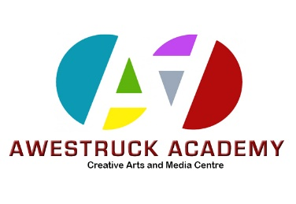
Awestruck Academy
36 Sylvania Way South
Clydebank G81 1EA
Contact awestruck-art@outlook.com Mob : 07412049120

Awestruck Sponsored Cycle June 26th 2021

From Awestruck to Bowling Harbour and Back

Participant Name ______________________ Total Amount Raised: £_____________
Name | Phone number | Email | Amount

